

North Lancashire Directions Group
Parent Carer Network

Event report
2012




Total number attending
Parents – 43
Children - 67

Ages of attending children with additional needs or disabilities
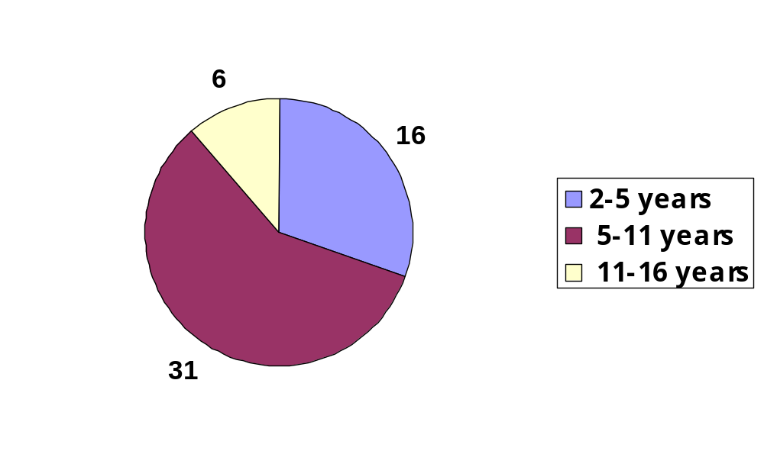

Additional needs / disabilities of attendees

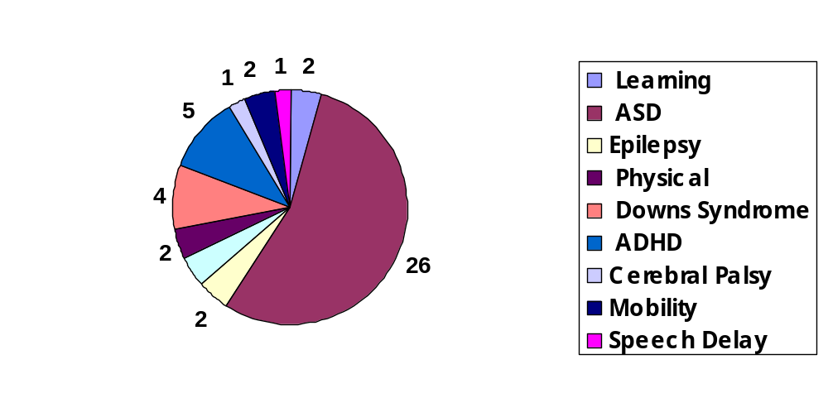

Attendee Location
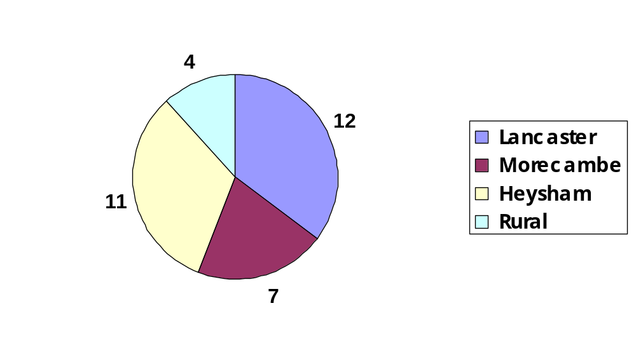
How parent carers heard of the event

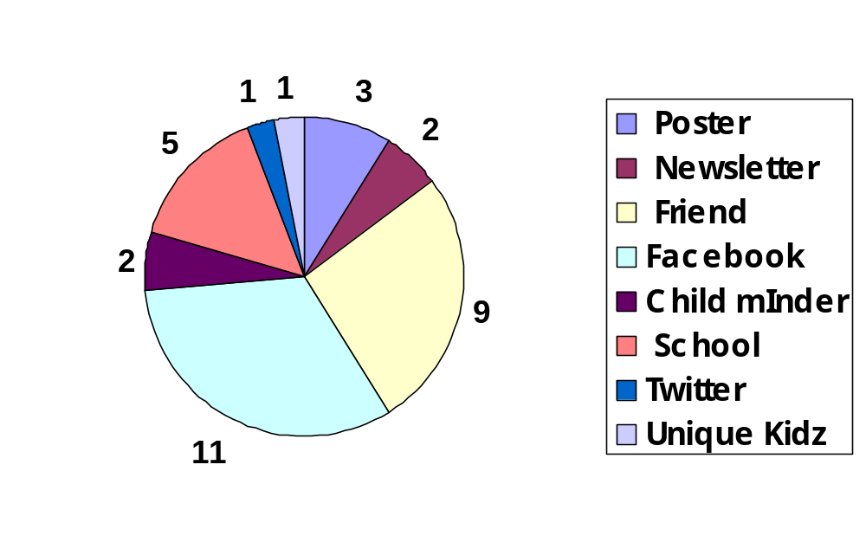

School Attended
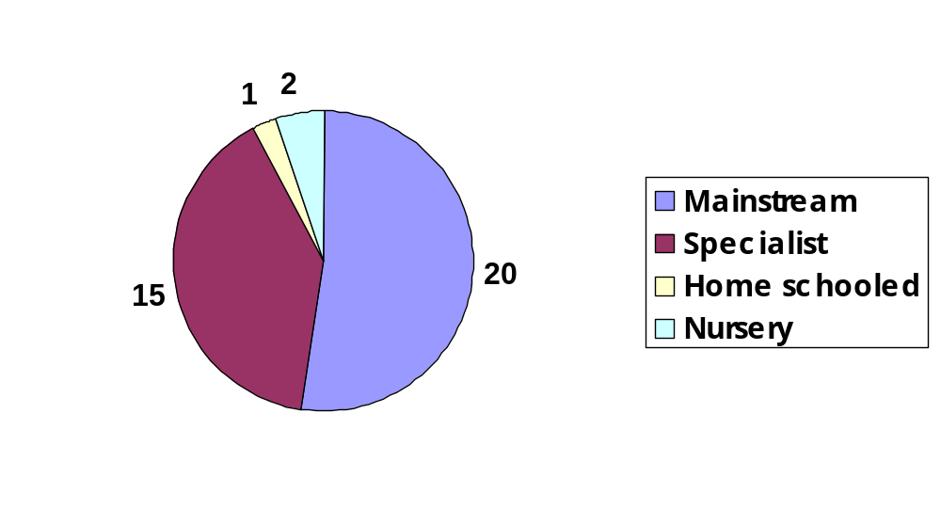

Main reason for families attendance

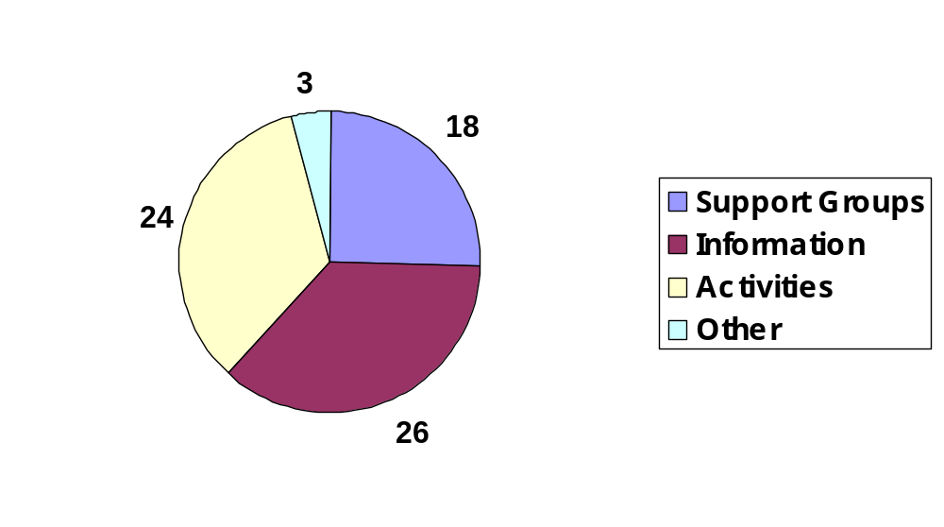

When asked if families had attended last year’s event, the response was

Yes 12 No 23

Of those who attended last year’s event, the following said they had accessed services as a result

3 FIND
3 Support groups
2 Lonsdale Carers
2 Parent Partnership Service
2 Salt Ayre sports centre
1 Family Fund

Graffiti Wall and feedback forms

The following headings were put on a sheet of paper which was put up in the Studio where the stall holders were. Parents were asked to add comments under the headings. Their responses were also collected from the feedback form s filled out when they left the event.

What I think I might need for the future

- Help from professionals for him to gain his full potential
- Advice re girl stuff
- Help when my child gets to high school
- More support

My biggest worry is

- Risk of abuse from others when older as vulnerable
- Bullying
- My child being a criminal
- When my child goes to high school
- Girl stuff into teenage years because she has additional needs
- Dealing with my child’s behaviour as he gets older and stronger

What I need for my child now

- More support
- Respite care in the holidays

What has helped me most?

- Support and friendship from other families with disabled children who understand where you are coming from.
- Cant say better than that (written underneath with an arrow pointing to the above comment)
- My friends support

What have you liked about today?

- Getting info on ADHD
- The help of staff
- The different activities for the kids
- Getting the information for if and when I need it
- Everything – we come every year!
- Overnight respite care details
- Finding out about the different activities on offer.
- We have thoroughly enjoyed our day and hope you run it again next year.
- It was a great day, thank you so much. Just was awkward with 3 kids and no one with me, but that’s the problem with being a single parent. Thank you xxx

Things I didn’t like about the day

- It clashed with a sports activity day at the Loyne School.
- Would have liked to have seen more families
- Would have liked some information on allergy sufferers support groups i.e. The Anaphylaxis Campaign or Allergy UK

Things I don’t like in general

- People when they patronise or pity you
- When other kids or adults look at you and give you funny looks.

What would you like to see in Lancaster and Morecambe for parents?

- Respite more accessible for children who don’t meet the eligibility criteria.
- More training / advice for parents on behaviour, sleeping etc.

Stall holders

Bay Childminders network
Help direct
NCompass / Carers Point
FASD forum for Autistic Spectrum Disorders
Safe Play Centre Preston
Mo-Ro's Morecambe Road play scheme
Unique Kidz and Co
Lancaster and Morecambe model engineering society ( Cinderbarrow Traintrack)
Parent Partnership
Lonsdale Carers / One Voice
Royal Cross School for the deaf
Lune Park Children's Centre / AOK club
Downs Syndrome Support Group
ADHD northwest

Activities on the day

Archery
Multi skills sessions
Sport and Play Officers – Arts and crafts
Boccia
Curling
Football Madness
Tai Chi
Disability Bikes

