Office use only
Family Ref No. |  | Courses requested
List |  | Lanc/More
Contacted |  | Accepted

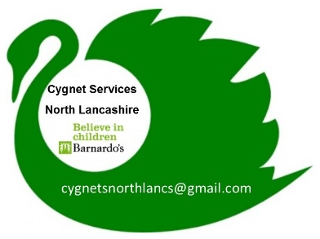
A six week (18 hrs) parenting support programme for parents/carers of children aged 5-18 on the autistic spectrum in North Lancashire.

CYGNET GROUP

Enrolment f o r m

If this enrolment form is not being completed by parents or carers, please ensure that all professional referrals have obtained permission from them to pass their details onto us.

Thank you

BASIC INFORMATION
Date: | Referrer (if not Parent or carer)  Address:  Tel number:  Email:
INFORMATION ABOUT PARENTS/CARERS
Parent/ Carer |  | Relationship to child:
Title: |  | Name:
Ethnicity: |  |  |  | Religion: |  |  | Preferred Language:
Home Tel: |  |  |  | Mobile: |  |  | Email:
Parent/Carer |  | Relationship to child
Title: |  | Name:
Ethnicity: |  |  |  |  | Religion: |  |  | Preferred Language:
Home Tel: |  |  |  |  | Mobile: |  |  | Email:

address information
Address:

Post Code:

Do you have a disability or is there additional Information you want to provide to help you attend a group: (i.e. access to a lift, literacy support)?

Preference for group
Lancaster |  |  | Morecambe / Heysham |  |  | Day |  |  | Evening

CHILD’S INFORMATION

Name: |  |  |  |  |  | Date of Birth:
Diagnosis: |  |  |  |  |  | Date of Diagnosis:
Diagnosed by whom: |  |  |  |  |  | Name of School:
Additional Information about your child/child in your care including what issues you are experiencing.

Do you have other children in your household? If so would you be interested in attending a further 3 sessions around siblings? Yes No
No. of other children and ages
If your child with an Autistic Spectrum Condition is over age 9, would you be interested in extra sessions around puberty, sexual wellbeing and relationships at a later date? Yes No

I agree to the programme coordinators processing information about me in order to provide the services.

I understand I may review this consent at any time. Please sign if you are happy for us to keep your details on our system.

I understand I must be able to commit to ALL 6 sessions of the programme to be given a place on the course.

Completion of the referral form is not a guarantee of a place on the course. Confirmation of your place will be sent via post/email prior to the start date.

Parent/Carer 1
Name:

Signature: Date:

Parent/Carer 2
Name:

Signature: Date:

admin use
Date entered on Programme List: | Received via:
Please return to:  Lucy Ellis (Cygnet Coordinator)  Barnardo’s Cygnet Programme  c/o Lune Park Children’s Centre  Owen Road  Lancaster  LA1 2LN  Tel: 07873818153  Email: cygnetsnorthlancs@gmail.com | Date received:

