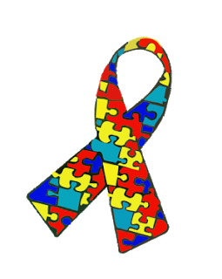 |  | Autism Passport
My name is;
I like to be called;
My NHS Number is;
Please read, important information about me.
It needs to be at the end of my bed. A copy should also be put in my notes.
If I need support before or during my stay in hospital the liaison nurses may be able to help. Contact them on:

Brian Evans – 01229406793, Mob:07813536877
brian.evans@mbht.nhs.uk
Morecambe Bay Hospitals

This Hospital Passport is based on original work by Gloucester Partnership NHS Trust, and subsequent work by Walsingham.
CONSENT TO INFORMATION SHARING AND IMPORTANT INFORMATION
This Autism Passport should be completed by you and the people who know you best.
By filling it in, you are consenting to your information being shared with the hospital and the staff who are caring for you.
The Autism Passport gives the hospital staff important information about you including any Reasonable Adjustments you may need to ensure that you get the best care, given in the right way for you. You can ask the hospital to take a photocopy and keep it in your file, a copy will be kept on the hospital computer to make sure hospital staff can access the information quickly if you forget to bring your Passport when you come to hospital.
Before you leave hospital make sure the Hospital Discharge Information Plan has been completed and remember to take your Autism Passport home with you.
Once you are home you may also want to fill in the Have Your Say questionnaire to tell the hospital about your experience. This will help them to improve their service.

If you require advice and support please contact the Hospital Learning Disability and Autism Specialist Nurse, Brian Evans
01229 406793 or 078135 36877

You can also discuss any worries or concerns you may have with the manager of the ward or department you are attending.
Any decisions made about your capacity to consent to treatment, best interests and resuscitation status must be made in consultation with you, your family, friends and other professionals.
I consent to this information being shared with the Hospital and agree to the Hospital saving this Hospital Passport electronically;

NAME |  |  | SIGNED (by the person or in their best interest in accordance with MCA (2005) | DATE

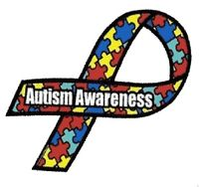AUTISM OVERVIEW TO HELP STAFF
Autism is a spectrum condition; people with Autism share certain difficulties, but will be affected in different ways. It is important to relate these difficulties to the challenges of being in a healthcare environment to facilitate the same outcome of treatments.
Social communication
- Difficulties with interpreting both verbal and non-verbal language like gestures or tone of voice.
- May have a very literal understanding of language, and think people always mean exactly what they say.
- May find it difficult to use or understand: facial expressions/tone of voice/jokes and sarcasm.
- Will often understand more of what other people say to them than they are able to express, yet may struggle with vagueness or abstract concepts, they may find it hard to understand the expectations of others within conversations, perhaps repeating what the other person has just said (this is called echolalia) or talking at length about their own interests.
Social Interaction
- Difficulty 'reading' other people - recognising or understanding others' feelings and intentions - and expressing their own emotions. This can make it very hard for them to navigate the social world. They may appear to be insensitive/seek out time alone when overloaded by other people/not seek comfort from other people/appear to behave 'strangely' or in a way thought to be socially inappropriate.
Repetitive behaviour and routines
- The world can seem a very unpredictable and confusing place to autistic people, who often prefer to have a daily routine so that they know what is going to happen every day. They may want to always travel the same way to and from school or work, or eat exactly the same food for breakfast.
- The use of rules can also be important. It may be difficult for an autistic person to take a different approach to something once they have been taught the 'right' way to do it. People on the autism spectrum may not be comfortable with the idea of change, but may be able to cope better if they can prepare for changes in advance.
Sensory sensitivity
- Autistic people may also experience over (Hyper) or under (Hypo) sensitivity to sounds, touch, tastes, smells, light, colours, temperatures or pain. For example, they may find certain background sounds (which other people ignore or block out), unbearably loud or distracting. This can cause anxiety or even physical pain. Or they may be fascinated by lights or spinning objects

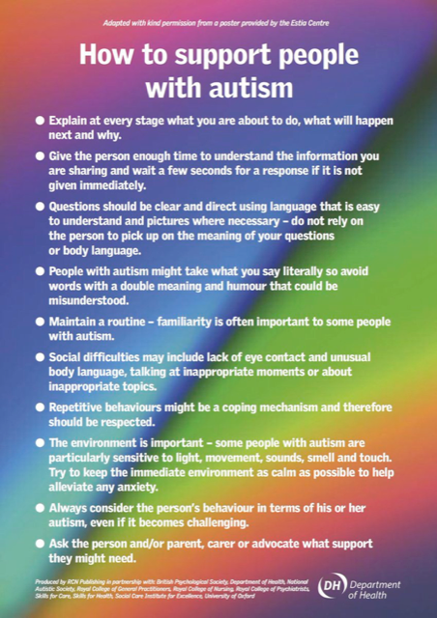


Mental Capacity Act 2005
THE MENTAL CAPACITY ACT 2005 SAYS A PERSON LACKS CAPACITY IF THEY;
- HAVE AN IMPAIRMENT/DISTURBANCE OF THE MIND OR BRAIN THAT AFFECTS THEIR ABILITY TO MAKE A SPECIFIC DECISION AT AN APPROPRIATE TIME.

- CAN THEY UNDERSTAND THE DECISION TO BE MADE?
- ARE THEY ABLE TO RETAIN THE INFORMATION?
- WEIGH UP THE INFORMATION TO ENABLE THEM TO MAKE AN INFORMED CHOICE?
- COMMUNICATE THEIR DECISION?
- WOULD THE SERVICES OF ANOTHER PROFESSIONAL HELP THE PERSON UNDERSTAND (e.g. SaLT, DEMENTIA,AUTISM OR LEARNING DISABILITY SPECIALIST)?
- IS THERE A NEED FOR A MORE SPECIALIST ASSESSMENT (e.g. MENTAL HEALTH ACT ASSESSMENT)?
IT IS IMPORTANT TO REMEMBER CAPACITY CAN VARY OVER TIME FOR SOME PEOPLE, CAPACITY SHOULD BE REASSESSED ACCORDINGLY

NAME OF THE PEOPLE WHO SHOULD BE CONSULTED AND INVOLVED IN THE CAPACITY ASSESSMENT AND BEST INTEREST DECISION PROCESS:
RELATIONSHIP:

PHONE NUMBERS:

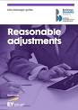
Reasonable Adjustments
(HOW BEST SUPPORT ME)
Reasonable adjustments that need to be made when going into hospital (Please consider any sensory and communication needs)
For example –a side room, my family to be able to come and visit/support me etc. outside of visiting hours, environmental changes, first appointment/double appointment, if planned procedure make provisions with me, family/carers to discuss my specific needs beforehand, prior visits to help with familiarity/de-sensitisation.
Identified adjustment | Reason/Rational

Things you must know about me (Personal details)

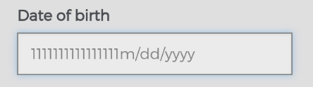 | Date of Birth
 | Address
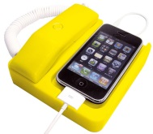 | Telephone
 | Current Living Environment | (Current living environment e.g. Flat, Bungalow, with whom)
 | Primary contact
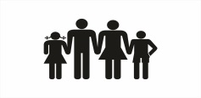 | Relationship
 | Address
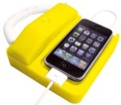 | Telephone
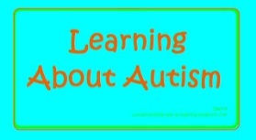 | Current Diagnosis | e.g. do you have a formal diagnosis of Autism or Asperger’s? Are there any other physical/mental health issues?

Things you must know about me (Personal details)

   | Religion
 | Religious needs
 | Ethnicity
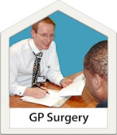 | Dr GP
 | Address
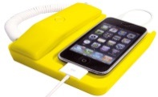 | Telephone
 | Other services and professionals involved with me
 | Allergies
 | Height -
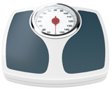 | Weight -

Things you must know about me (My Health and Wellbeing)

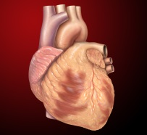  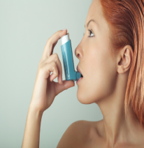 | My heart or breathing problems
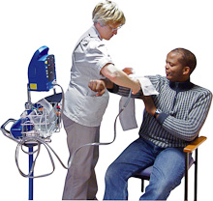 | Medical interventions (how to take my blood, blood pressure, give injections)
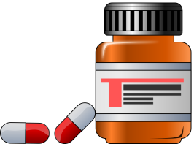 | My current medication | Medication correct at time of entry. Please check my current medication (ask for a prescription sheet).
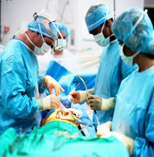  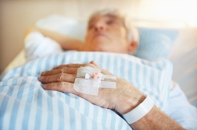 | Operations and illnesses I have had

Things you must know about me
(How I communicate)
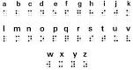

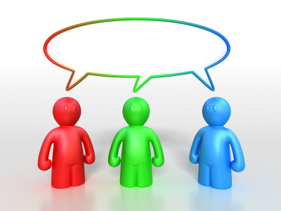
How to communicate with me (e.g. verbally, give time to process information, signing, pictures, objects of reference social stories etc.) | How I communicate  (e.g. verbally, I may need longer to express myself please be patient, signing, written etc.)

Things you must know about me
(How I experience the World)
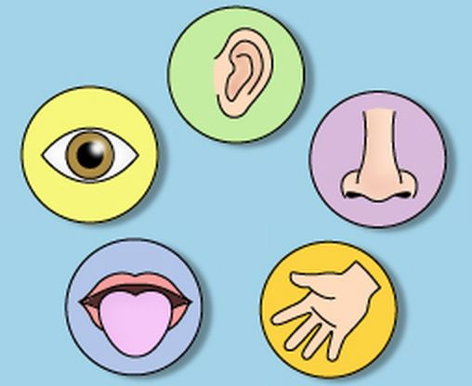
SENSORY ISSUES AND SENSITIVITY
SENSORY EXPERIENCE  - SIGHT/VISION, the way the world is viewed may be distorted in a variety of ways, central vision is blurred but peripheral vision is sharp and visa -versa, colours may appear to move around or you may appear to be looking through a kaleidoscope, images may fragmented, objects may appear closer or further away than they actually are. You may focus on a specific detail rather than the whole object.  - SOUND/AUDITORY, some people may experience sensitivity to specific sounds e.g. sudden, high pitched, complex noise etc. this may affect your ability to focus and concentrate on what others are saying this may be a constant distraction (Hyper). Or you may enjoy noisy crowded places, banging doors and object, it may be difficult for you to acknowledge particular sounds or filter sound (Hypo)  - SMELL/OLFACTORY, some people may have no sense of smell, you may need to lick things to get a better sense of what they are (people say they can taste smells) it may be difficult to differentiate between smells; you may seek strong smells (Hypo). You may avoid smells, dislike certain smells e.g. perfume, cleaning products, some smells might be overpowering and ‘painful’, you may detect smells others can’t smell (Hyper) | SPECIFIC SENSORY NEEDS  (please detail any sensory differences you experience to help us plan your care)

- TASTE/GUSTATORY, some people may limit themselves to bland food, you may be labelled as being a ‘picky eater’ some food may be overpowering for you because of your sensitivity (Hyper). Others may crave strong tasting food for example spicy food, curry etc. you may eat or mouth non-edible items in an attempt to satisfy the need for strong tasting things (Hypo).

- TOUCH/TACTILE, Some people may have a low response to pain (this does not mean you have a high pain threshold!) you may be a poor informer of pain and illness, you may seem clumsy, have a weak grip/enjoy holding/feeling heavy objects and enjoy certain textures (Hypo) others may avoid sensation and touch, you may avoid certain fabrics/clothing, avoid some daily activities e.g. washing, brushing hair/teeth because it is painful, you may describe light touch as painful but enjoys firm consistent pressure/touch (Hyper).

- VESTIBULAR/MOVEMENT AND BALANCE, this is situated in the inner ear our vestibular system helps us maintain our balance and posture and helps us understand how fast our body is moving, you may need to rock, swing, spin or be in constant motion to get sensory feedback and stop the world moving (Hypo) or you may find movement or stopping movement difficult, coordination is problematic e.g. using stairs, being in a car or playing sports (Hyper).

- PROPRIOCEPTION/JOINTS AND MUSCLES, this is awareness of where your body is in space and how different parts of our body is moving, You may stand too close to people because you can’t judge proximity or need to touch thing to establish where you are in space, you may bump into things and appear clumsy (Hypo). You may struggle with fine motor skills e.g. Manipulating things like buttons or laces, or turn your whole body to look at things (Hyper).

Things you must know about me
Things I like
e.g. what makes me happy, things I like to do such as watching TV, reading, music and my routines
Things I don't like
e.g. crowds, loud noises, some food and being touched.

Things I like |  |  |  | Things I don't like
 |  | Please do these things |  |  |  | Don't do these things
Completed  by: |  |  | Date: | 00/00/00 | Review Date: |  | 00/00/00

Discharge
What people need to do before I leave hospital:

When planning for me to go home you need to talk to:
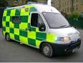

I will need transport to get home from hospital:
(Please highlight)

Yes No

What’s changed?
About my health, medication and support needs?

What do I need now?
To make sure my changed needs around health, medication or support are met?

This passport belongs to me.
Please return it when I am discharged.

