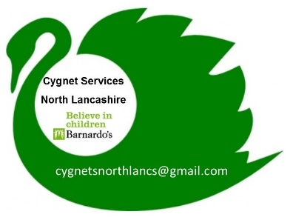

Cygnet for practitioners

A 2 day training programme for professionals working with children and young people aged 5-18 and their families with a diagnosis of an Autistic Spectrum Condition.

CYGNET for practitioners training

Enrolment form

Course attendee BASIC INFORMATION
Please complete if you are wanting an individual place or if you are representing a service for group delivery request.
Name: | Email: |  | Phone No:
Job Title: | Based at: |  | Area of Lancashire you deliver your service in:
Please describe your connection to children / young people and their families and how this course would benefit your area of work.
If completing on behalf of your organisation for a group course delivery

Number of attendees for the course
Which service do you represent?
Who does your service support?

Do you have a disability or is there additional Information you want to provide to help you attend a group: (i.e. access to a lift, literacy support)?

I have been provided with written information about the service and have had explained:

- what information they will collect, why and what they will use the information for;

- that the records may be kept in paper files or on electronic systems and may include photographs, videos and other personal information;

- That information will be held in confidence and the limits to confidentiality.

- The programme coordinator has encouraged me to raise questions and concerns at any stage whilst we work together.

North Lancashire Directions Group & Morecambe Bay Hospitals

CYGNET FOR PRACTITIONERS

Dates for training – To be confirmed
Day One |  | Day Two

I agree to the programme coordinators processing information about my organisation in order to provide the services.

I understand I may review this consent at any time. Please sign if you are happy for us to keep your details on our system.

Completion of this form is not a guarantee of a place on the training. Confirmation of your place will be sent via post/email prior to the start date.

Course fees must be paid within 60 days of training completion.

Signed | Date

admin use
Date entered on Programme List: | Received via:
Programme Information Leaflet Sent Yes No  Privacy Notice Sent Yes No | DPA Consent Received Yes / No  Date received:
Invoice sent via | Invoice paid :
Sign Off: Cygnet Co-ordinator

Signed:………………………………………………………………

Date:………………………………………………………………..

Place allocated YES NO

Course block allocated

Details passed to CFP trainers
Please return to:
Lucy Ellis (Cygnet Coordinator)
Barnardo’s Cygnet Programme
c/o Lune Park Children’s Centre
Owen Road
Lancaster
LA1 2LN

Tel: 07873818153
Email: cygnetsnorthlancs@gmail.com




