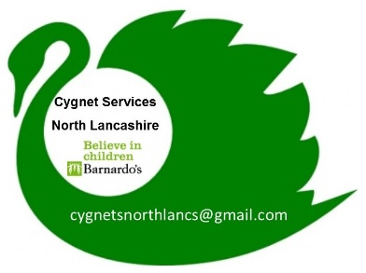

Cygnet for practitioners

A 2 day training programme for professionals working with children and young people aged 5-18 and their families with a diagnosis of an Autistic Spectrum Condition.

CYGNET for practitioners training

Enrolment form

Course attendee BASIC INFORMATION
Please complete if you are wanting an individual place or if you are representing a service for group delivery request.
Name: | Email: |  | Phone No:
Job Title: | Based at: |  | Area of Lancashire you deliver your service in:
Please describe your connection to children / young people and their families and how this course would benefit your area of work.
If completing on behalf of your organisation for a group course delivery

Number of attendees for the course
Which service do you represent?
Who does your service support?
Do you have a disability or is there additional Information you want to provide to help you attend a group: (i.e. access to a lift, literacy support)?

North Lancashire Directions Group & Morecambe Bay Hospitals

Dates for training - For each attendee please indicate which course you require a place on (choose one Day One & one Day Two date)
Day One 12th Feb |  | Day Two 14th March
Day One 23rd May |  | Day Two 20th June
Day One 8th Oct |  | Day Two 14th Nov

I understand I may review this consent at any time. Please sign if you are happy for us to keep your details on our system.

Completion of this form is not a guarantee of a place on the training. Confirmation of your place will be sent via post/email prior to the start date.

Signed | Date

admin use
Date entered on Programme List: | Received via:
Sign Off: Cygnet Co-ordinator

Signed:………………………………………………………………

Date:………………………………………………………………..

Place allocated YES NO Course block allocated

Please return to:
Lucy Ellis (Cygnet Coordinator)
Barnardo’s Cygnet Programme
c/o Lune Park Children’s Centre
Owen Road Lancaster LA1 2LN
Tel: 07873818153
Email: cygnetsnorthlancs@gmail.com

