Acorn Psychology Services
Summer Holidays
For many weeks now children have been educated at home or in small groups in school. With the summer holiday just around the corner it is important for children to feel they can now take a break from structured education and make the most of their summer holiday. Even without formal learning there are many ways that children can develop their skills over the summer, included in this leaflet are just a few ideas:

- Play

- Keeping active throughout the summer

- Emotions and managing behaviour

Play
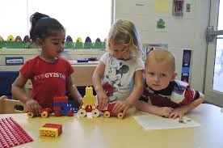
Play is an essential part of every child’s life and is vital for the enjoyment of childhood as well as social, emotional, intellectual, and physical development. Research shows that play has many benefits, recent research suggests that children’s access to play can:
- increase their self-awareness, self-esteem, and self-respect
- improve and maintain their physical and mental health
- give them the opportunity to mix with other children
- allow them to increase their confidence through developing new skills
- promote their imagination, independence, and creativity
- offer opportunities for children of all abilities and backgrounds to play together
- provide opportunities for developing social skills and learning
- build resilience through risk taking and challenge, problem solving, and dealing with new and novel situations
- provide opportunities to learn about their environment and the wider community.
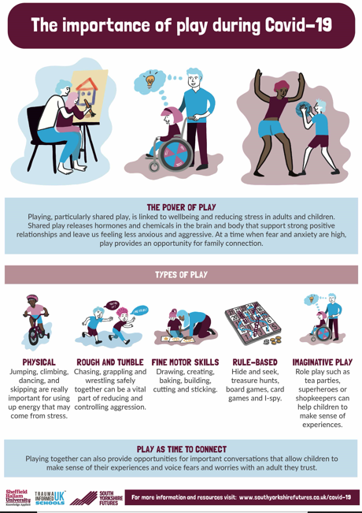
Although we are no longer in full lockdown, the above resource has some great ideas relating to play, especially given this summer could well be different than others due to Covid-19.
Great Ormond Street have come up with a lovely list of games and activities to try - https://www.gosh.org/power-of-play-hub/games-and-activities
Keeping active throughout summer
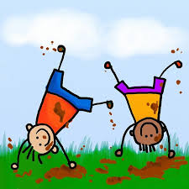
To increase a sense of wellbeing, improve sleep quality and maintain good physical development the government guidelines suggest children should aim for 60 minutes of exercise each day. Besides the health benefits, improved gross motor skills (moving our bodies, arms and legs) can have a direct impact on developing good fine motor skills (such as writing and threading etc). And finally, exercise is a great way to have fun with others as well as on your own!

Outdoor and indoor game ideas for physical play with a parent or other children
Bubble pop: One player blows the bubbles and the other/s take turns in popping them. This can also be used as a challenge for the children wanting to pop and a good way to exercise self-control and turn taking. The child will be told to pop the bubbles with their hands or feet or elbow, etc.
Balloon balance: Each player must balance a balloon between a body part and walk across room without using hands.
Balloon tennis: People hit the balloon through the air to each other without letting it drop. Use ping pong paddles or racquets made out of paint stir sticks and paper plates.
Popcorn: Children squat, pretending they are kernels of corn waiting until they hear the number 10. You start counting 1, 2, 3, 4…At 10; they go off, going from a squat to a full jump and then jump all around, forward and backward until you start a new batch of popcorn. Then you can eat them all up
Duck walk: Duck walk; crab walk; frog jump; kangaroo hop; elephant walk; lobster walk; inchworm glide; chicken walk; bunny hop; seal walk.
Beanbag balance: Who can walk the furthest with an item balanced on their head (such as beanbag or cushion)
Bean Bag catch: See how many throws/catches the two or more people can do in a row.
Fast Firefighter: Each player places their coat on the back of a chair. The lights are turned out and curtains closed, the players must move quickly to put on their coats, sip/button them up and sit down.
Fire practice: each player lies on their bed and when a sound is played, everyone practices how they might get out of the house if there was a fire in the night.
I Spy finder: The first player says “I spy with my little eye, something that is green (or round, skinny, tall, or whatever).” The other player/s have to run around the room pointing to as many things as they can of that colour/shape/description- the first player shouts out when they touch the correct item.
Stack the items: The players sit side by side. At one end of the room place a stack of items. On ‘3,2,1 go’ each player has to stand up, run to grab their item and go back to their seat. Once sat, they immediately repeat, standing up again to go and get a second item. The items are stacked, the one with the highest pile wins.
Walking Fun: How many ways can children walk? Have them try walking like a robot, baby, speed walker, giant, and ballerina. Have them think of other ways to walk and do that, too.
Try to see insects on a walk, when you see them, make a list then practice moving in the way they do (e.g. butterfly flying or worm wiggling).
Hokey-Cokey and other traditional movement songs (accessible by searching Youtube).
The Change for Life website has some great ideas for Disney related indoor exercise activities:
https://www.nhs.uk/change4life/activities/indoor-activities
Emotions and managing behaviour during the summer break
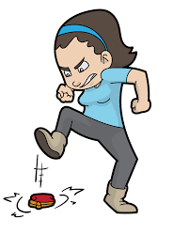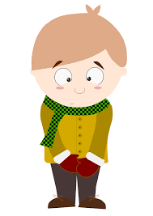
While children and young people may embrace the reduced structure of the school holidays, others can find it more difficult. Here are some strategies to support children who might be struggling to cope:
- Have a structure for the day, include the child in the decision making and creating a list or a comic strip showing what is happening. This doesn’t need to include times, but a block system where ‘morning,’ ‘afternoon’ and/or ‘after dinner’ could be used. Children are more likely to follow plans that they have been involved in creating.
- Make a list together of activities that the child could participate in on their own and another list for shared activities. They can be directed to this when they appear to be struggling with not knowing what they want to do. Again, this can be written, drawn or include printed images from the internet.
- Include physical activity each day as this is a significant factor in personal wellbeing of children, young people and adults.
- Offer children who frequently become frustrated a place there they can choose to go when they are feeling overwhelmed or frustrated. This might be a small tent in their bedroom, a small space behind the sofa or a blanket over a couple of chairs. This can work well if they are given time and space to calm and come out when they feel ready to reengage with the family.
- Chill out! Children can become overly warm without noticing, which in turn can result in them feeling emotional or angry. Getting outside into a paddling pool, using watering cans or old washing-up bottles to squirt water at themselves or each other, or even a shower/play in the bath is a great way to cool down and calm down in summer.

